DAY 7 :

**(FUNCTIONS)**

**1. Write a program in C to find smallest of three numbers using functions. 2. Write a program in C to calculate area of a triangle using function. 3. Write a program in C to calculate P(n, r) using function. 4. Write a program in C to calculate C(n, r) using function. 5. Write a program in C to sum the series---**

**1/1!+ 4/2!+27/3!--------------------------upto n terms**

**6. Write a program in C to Check Whether a Number can be Expressed as Sum of Two Prime Numbers and print all possible combinations. 7. Write a program in C to swap two numbers (i) using call by value (ii) using call by reference**

**8. Write a program in C to print a table of binomial coefficients which is given below: Given an integer max, print binomial coefficients table that prints all binomial coefficients B(m, x) where m and x vary from0 tomax. 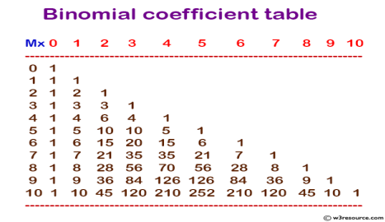Consider the formulas given below:**

**B(m,x) = m!/(x! (m-x)! where m>x and B(m, 0) =1, B(0,0) =1 and B(m,m) =1 and B(m,x) = B(m,x-1) *(m-x+1)/x**

**9. Write a program in C to calculate factorial of a number using recursive function.**

**10.Write a program in C to calculate GCD/HCF of two number using recursive function.**

**11.Write a program in C to print a table of binomial coefficients given in question 8. using recursive function.**

**12.Write a program in C to calculate Ackermann Function:**

